[**NOTE: -** To host your Java Web Application on *AWS* using *Elastic Beanstalk* service,  
you need the **“.war”** file of your application. Keep the **.war** file ready.]

How to Create AWS Account? Click –

[**AWS - Account Creation.pdf**](https://drive.google.com/open?id=1eFMi_RyNu7N8L4Mk5DnafJafr8sVWd5d)

1. Login to AWS Management Console

* Go To -  
   <https://aws.amazon.com/>
* Click on “**Sign In to the Console**” button.

**OR**

Hover the mouse pointer to “**My Account**” drop down menu and click on “**AWS Management Console**”

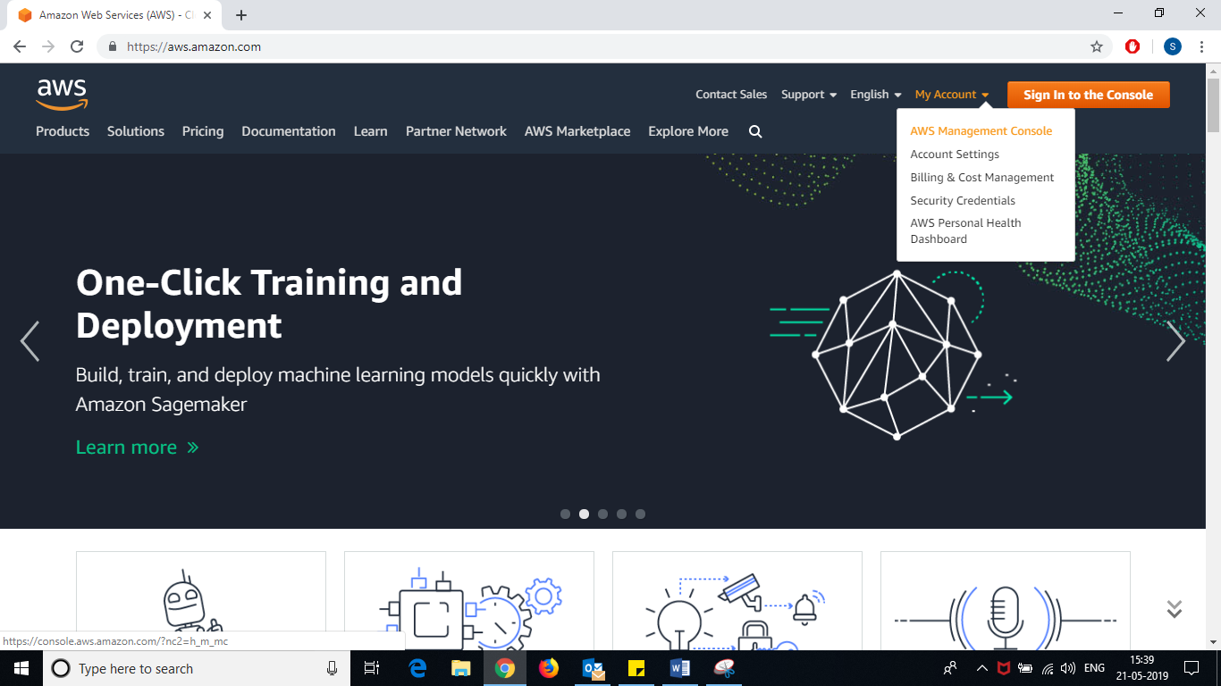

* Enter **Email Id**
* Click on “Next” button

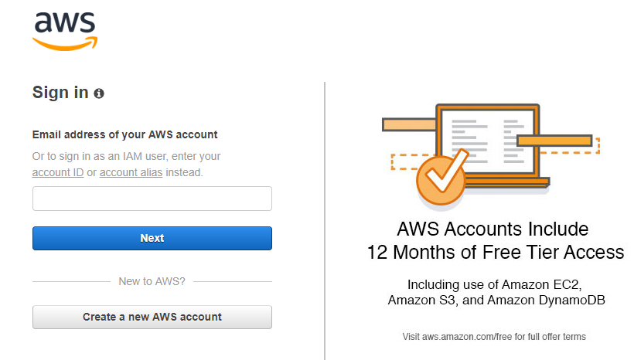

Enter your **email id** used to create AWS account.

* Enter your password
* Click on “**Sign in**” button.

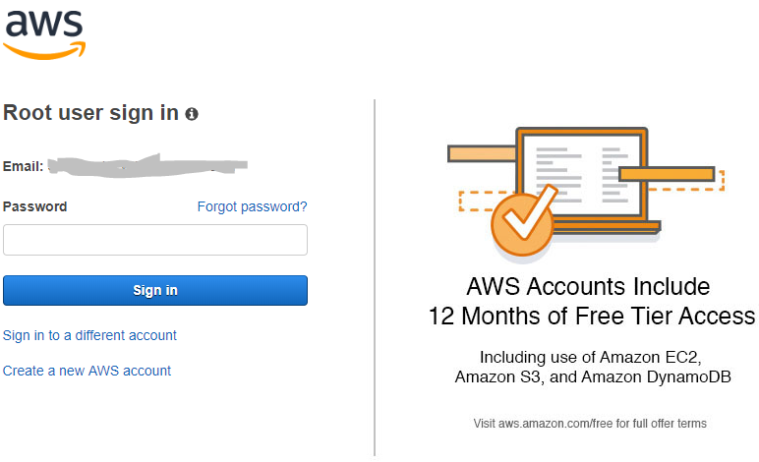

1. On the top right corner (next to your AWS Account Name), **change the region (location)** to “**Asia Pacific (Mumbai)**”

* Hover mouse to Ohio or whatever location it shows (next to your AWS Account Name).
* Select “**Asia Pacific (Mumbai)**” from the drop down list.

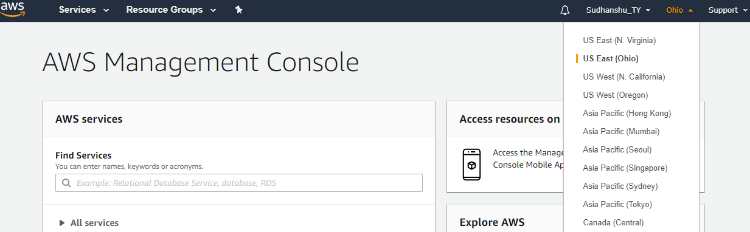

1. Expand “**All services**” 🡪 under ***‘Compute’*** select “**Elastic Beanstalk**”.

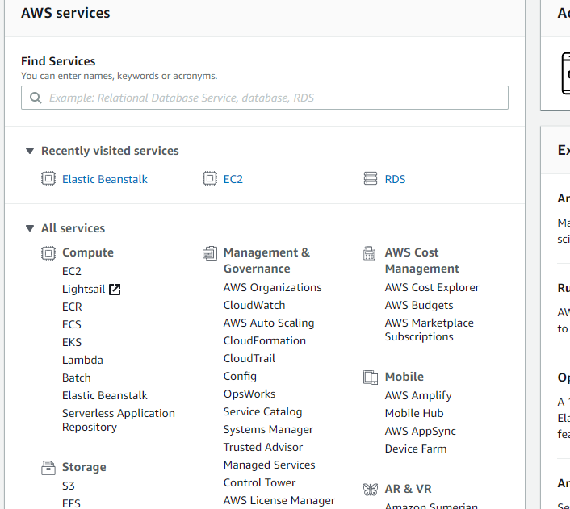

1. Click on “**Get Started**” button –

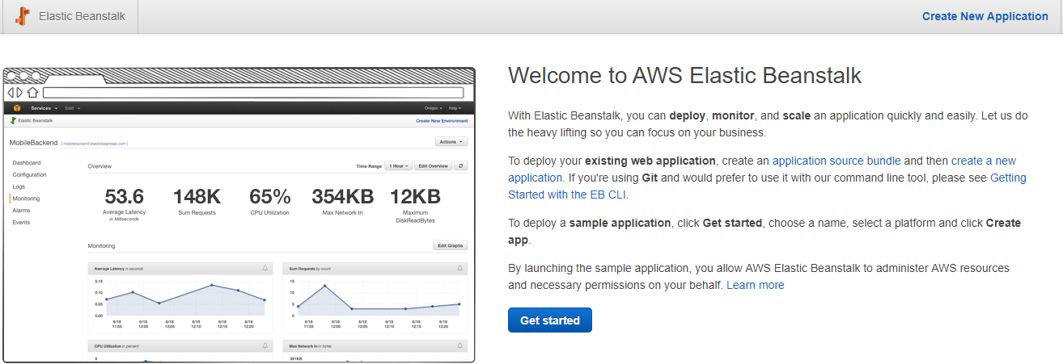

1. Enter “**Application Name**”, select “**Tomcat**” from *“Platform”* dropdown, select “**Upload your code**” radio-button against *“Application code”* and click on “**Upload**” button –

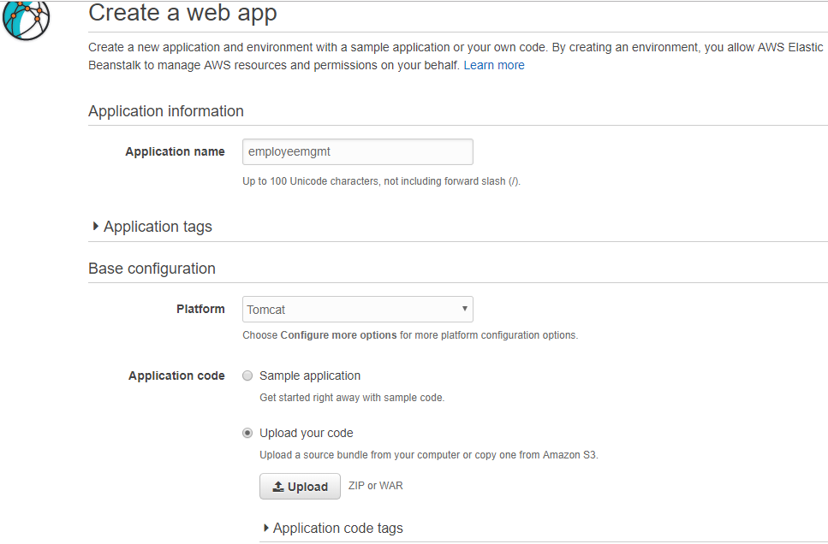

1. Choose your “**.war**” file, change the label or *keep it default* and click on “**Upload**” button –

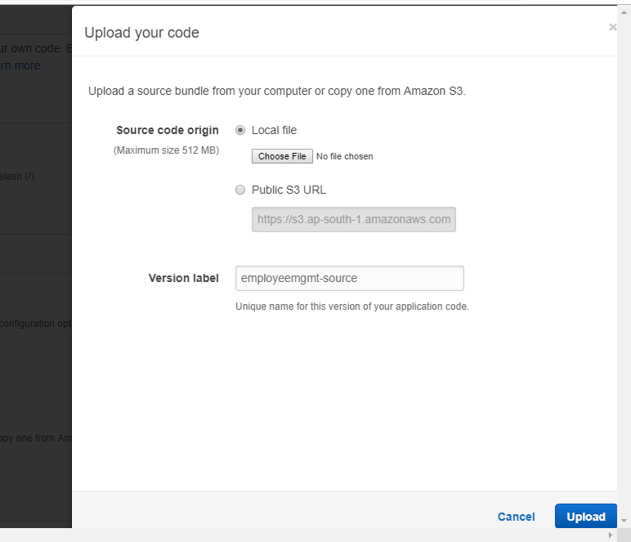

1. Click on “**Create Application**” button –

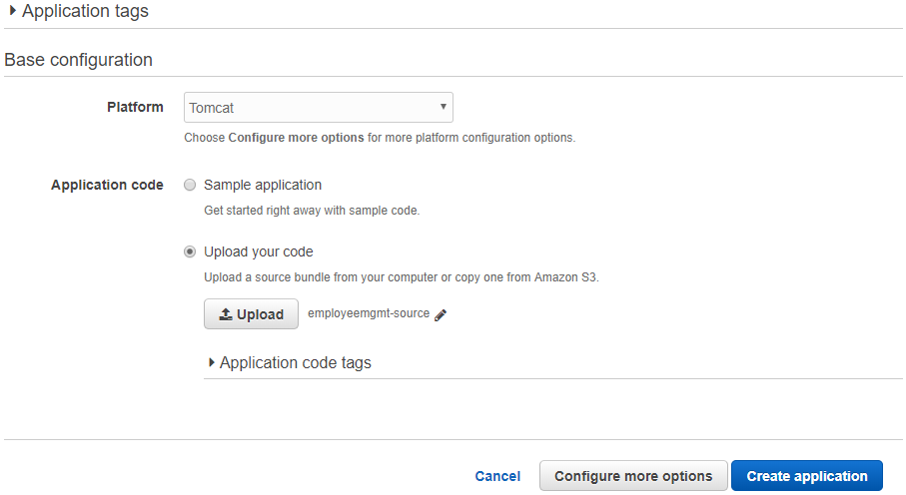

1. 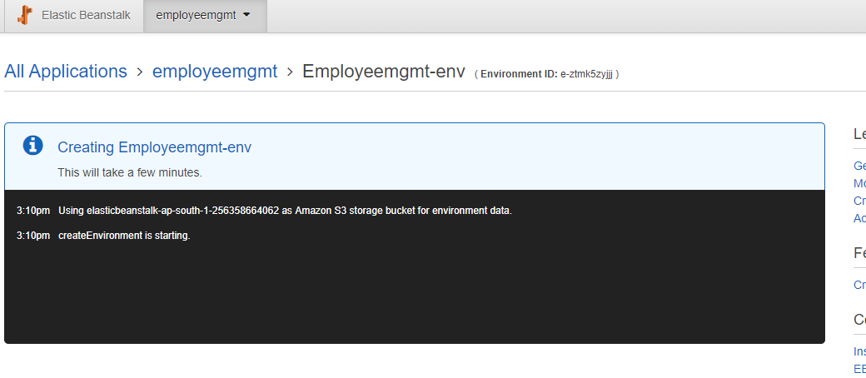It will take some time to Create the application. ***Wait*** *until it is created*.
2. Once it is completed, *find the* ***URL*** to access your application –

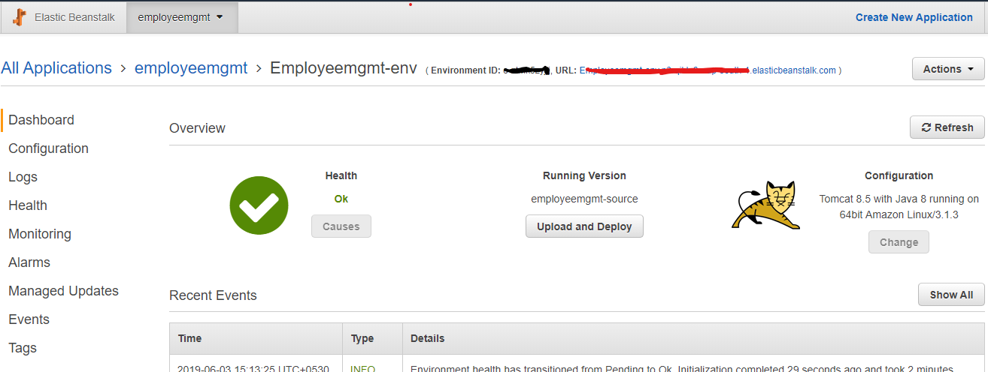

Here will be the URL for your application.